**Capabilities covered:**

* Eclipse IDE for programming Java application
* Analyse complex business scenarios and create a data model
* Use Java to implement business layer of your application
* Handle exceptions to maintain the normal flow of the application.
* Configure Environment to create RESTful web services using Spring Boot
* Use Hibernate/JPA framework to implement basic DAO layer
* Automate the build using Maven
* Implement unit testing

**Note:**

1. Do not change the table structures.
2. **READ THE QUESTION PAPER COMPLETELY BEFORE YOU START CODING.**
3. Use appropriate data types and precisions for the variables
4. Handle all exception and alternate flows
5. Loose coupling: Create a separate Dao interfaces and implementation classes. Database interaction code should be only in DAO classes.

# **Problem statement: DTH Channel subscriptions**

Create a Rest API based application to manage information about Direct to Home subscribers. The application should allow users to subscribe for channels of his/her choice **(one customer can subscribe for many channels).** Also the subscriber should be able to view the channels he/she has subscribed for and the total subscription cost for the channels selected.

Pre-condition for the application is that the following tables should be created:

* CUSTOMER table with columns (SUBSCRIBER_ID, REGISTERED_MOBILE, FIRST_NAME, LAST_NAME)
* CHANNELS with columns (CHANNEL_ID, CHANNEL_NAME, COST_PER_MONTH)

SAMPLE DATA is shown below:

**CUSTOMERS:**

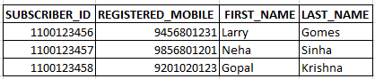

**Note:** Create a Stored Procedure to insert records into **‘CUSTOMERS’** table. [Provide database scripts file for creating stored procedure and inserting records].

**CHANNELS:**

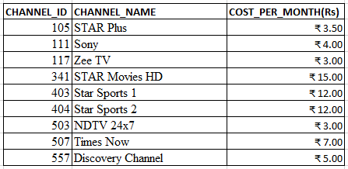

**Note:** Create a Stored Procedure to insert records into **‘CHANNELS’** table. [Provide database scripts file for creating stored procedure and inserting records].

Provide all the DDL and DML database scripts used for creating tables and records inserted. Insert at least 3 CUSTOMERS and 5 CHANNELS. Note that SUBSCRIPTION_ID is 10 digits and CHANNEL_ID is 3 digit

## **1. Subscribe for channel.**

User should enter “Subscription ID”, “channel” and date of submission as input

On successful submit Subscription details should be added in the new database table **(Subscription_Channel)** as shown below.

**The column ‘Id’ must be auto generated.**

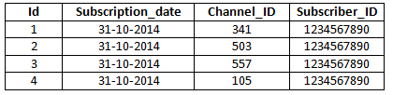

Following validation has to be done:

1. All fields are mandatory.
2. User should select Channel.
3. Date should be a valid date

## **Screen 2: Edit Subscription**

User can unsubscribe channel using input as “Subscription ID” and “channel”

On successful submit of details should be removed from **Subscription_Channel** table

## **Screen 3: Customer Subscription details**

Once User enters “SUBSCRIPTION ID” as input and display “View Subscription Details” has to be listed as shown below . The information contains all the channels the customer has subscribed for, cost per month of each channel, total cost of subscription (Rs.100 for set top box + sum(cost of all channels) customer has subscribed for, Customer name)

